# iBudget Project Requirements

## Purpose and Scope Statement

The purpose of iBudget is to provide users with an efficient and user-friendly platform to manage their financial records. By enabling users to track their income and expenses, set monthly budgets, and visualize spending patterns, iBudget empowers individuals to maintain better financial discipline and make informed financial decisions.

iBudget is a personal finance management application designed for users to record and track their financial transactions. The app includes the following features:

* User Authentication: Secure user registration and login to protect financial data.
* Expense and Income Recording: A simple interface for recording daily expenses and income.
* Monthly Overview: A homepage displaying a summary of the user's monthly expenses.
* Budget Management: Users can set custom monthly budgets to monitor and control spending.
* Visualization Tools: Interactive pie charts to illustrate spending patterns by category.
* Financial Reports: Month-wise and year-wise summaries of income and expenses for better financial analysis.

The app focuses on providing a seamless and intuitive experience, ensuring users can effectively manage their finances without complexity.

## Requirements Narrative

Users can perform the following functions

1. View current bill
2. View monthly expenses
3. View yearly expenses
4. View profile
5. Choose different months
6. Add a expense record
7. Add a income record
8. Delete a record

## Objectives

User login:

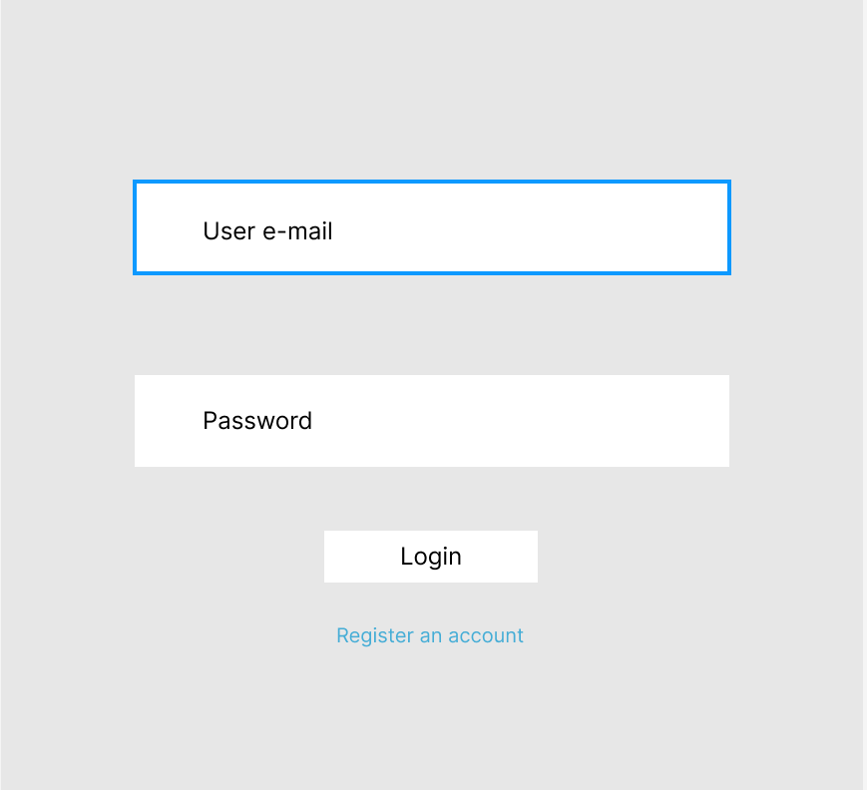

Register:

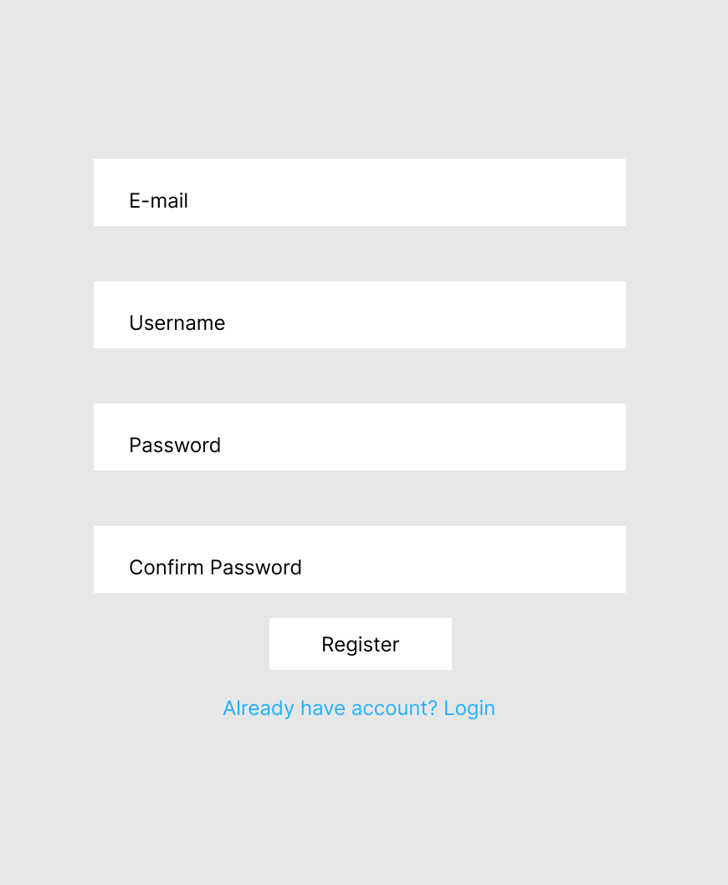

Home:

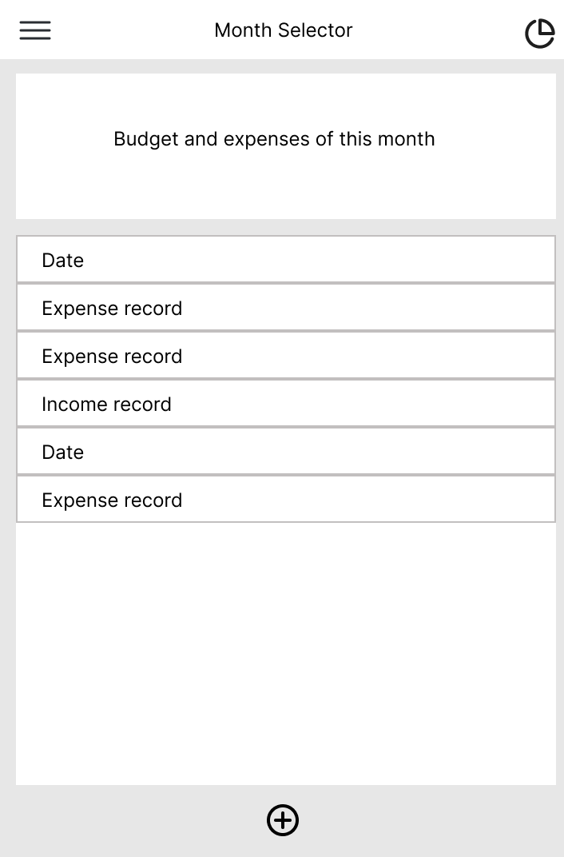

Side Bar:

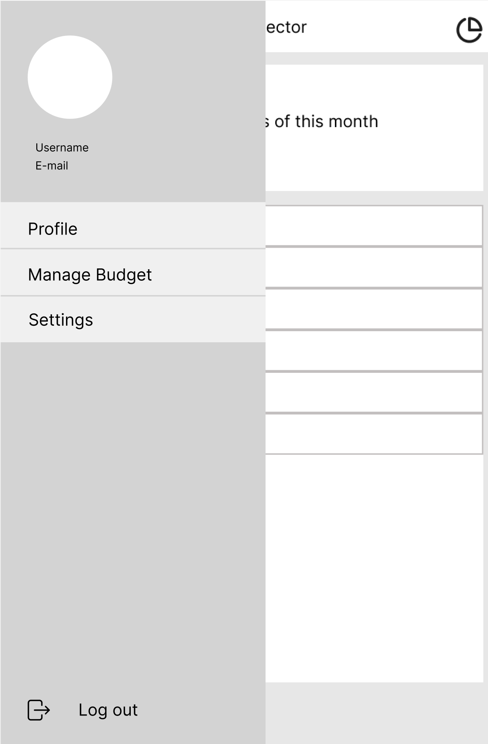

Profile:

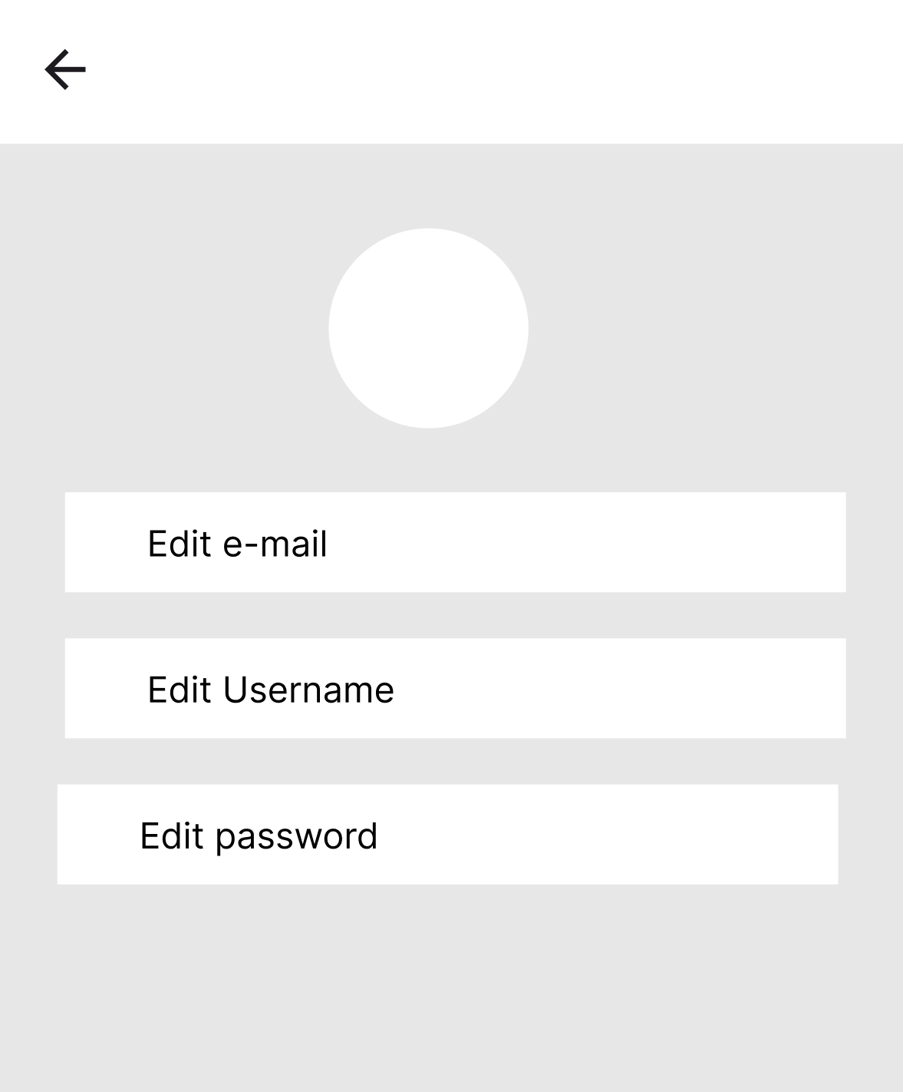

Edit Budget:

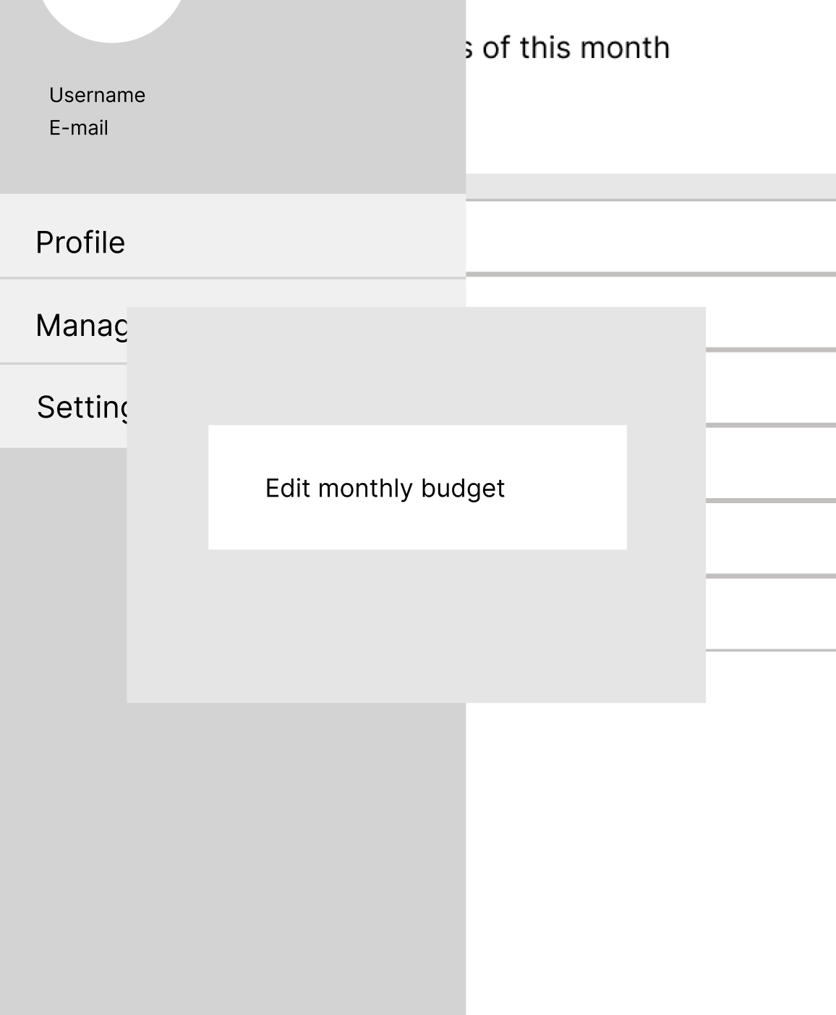

Add record:

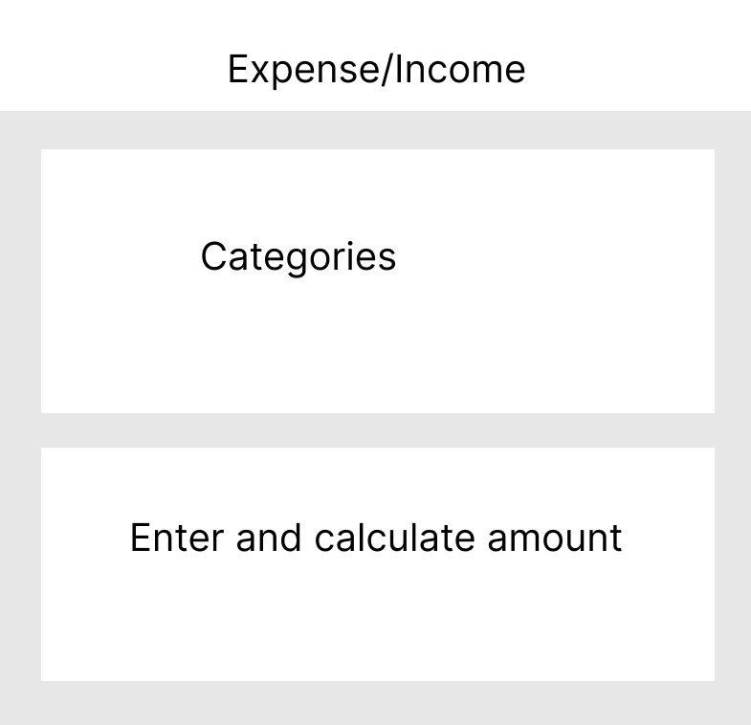

Overview:

